**National Textile University, Faisalabad**



**Department of Computer Science**

|  |  |
| --- | --- |
| **Name:** | Muhammad Abdur Rehman |
| **Class:** | SE-B |
| **Registration No:** | 23-NTU-CS-1180 |
| **Lab:** | 1-5 |
| **Semester:** | 4th |
| **Course Name:** | SCD |
| **Submitted To:** | Miss Kalsoom Safdar |
| **Submission Date:** | 25-April-2025 |

**Lab 1:**

*Introduction to OOP*

**Code:**

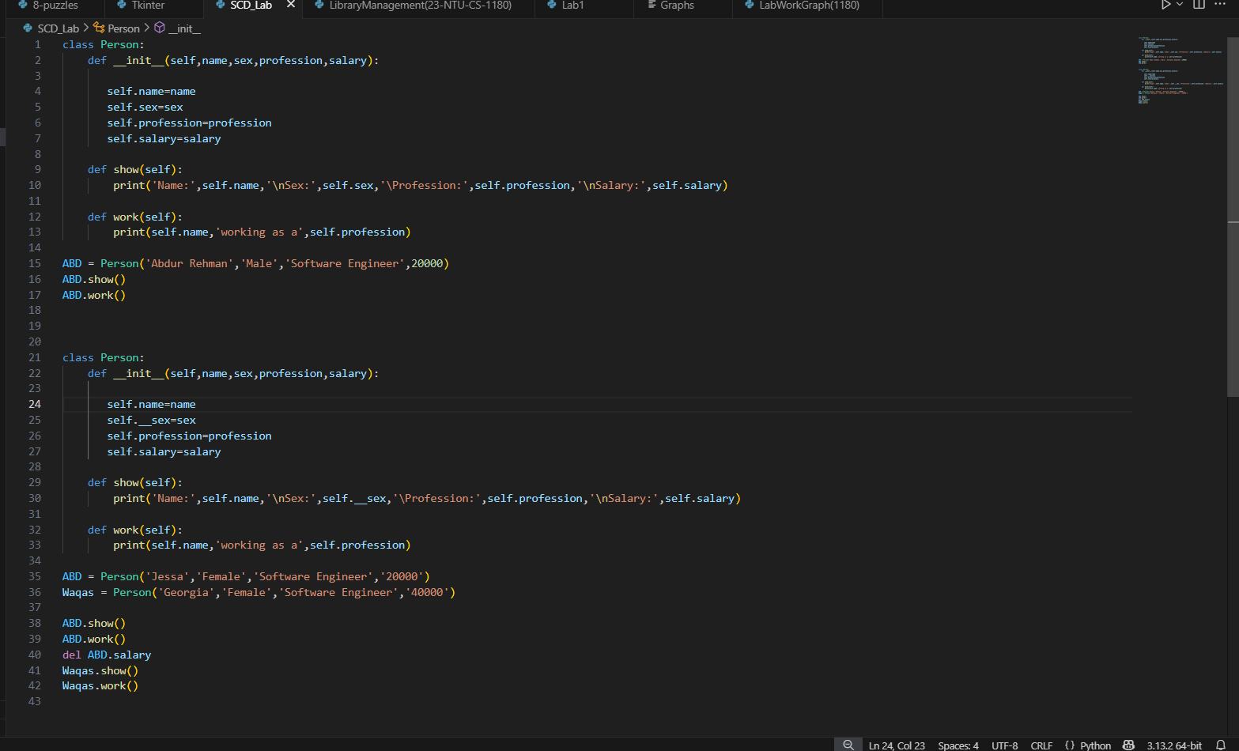

**Output**:

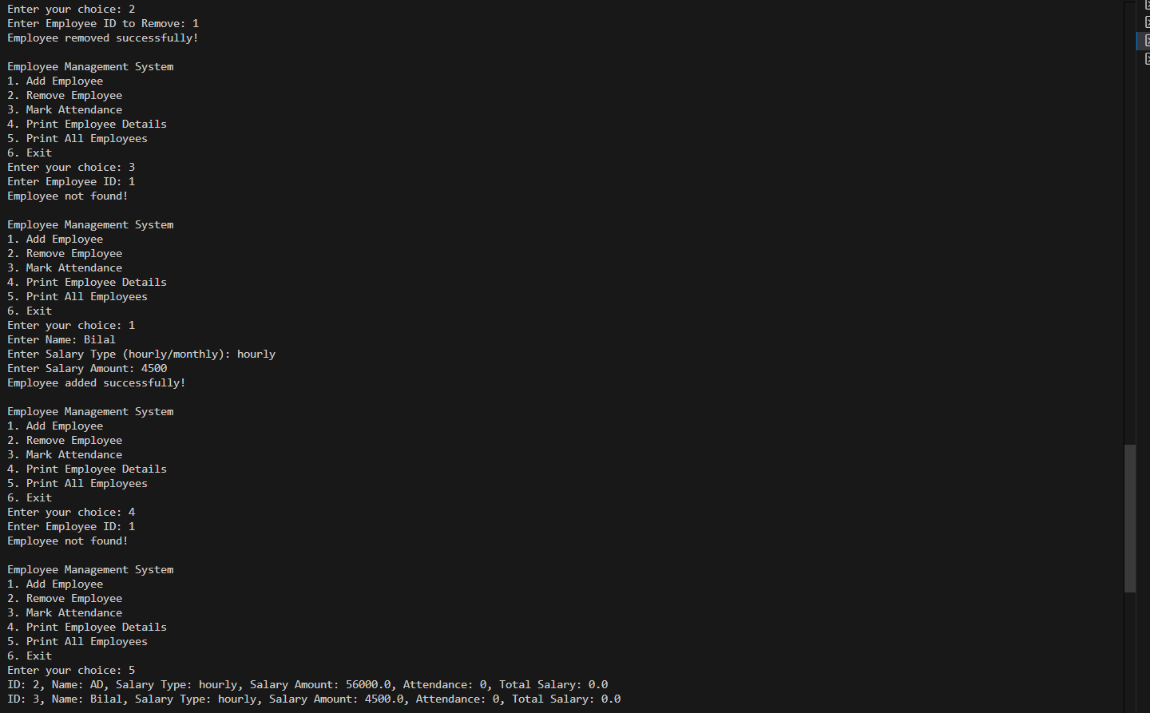

**-------------------------------------------------------------------------------------**

**Lab 2:**

*Library management System*

**Code:**

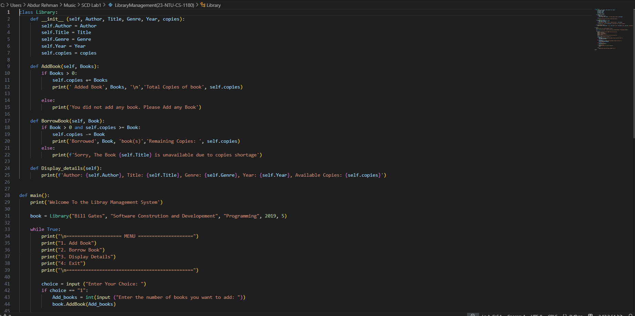

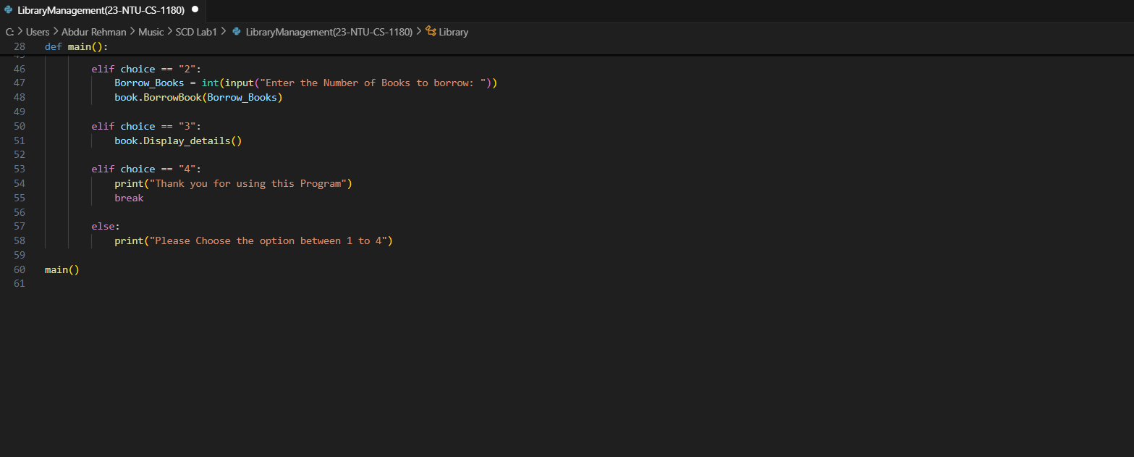

**Output**:

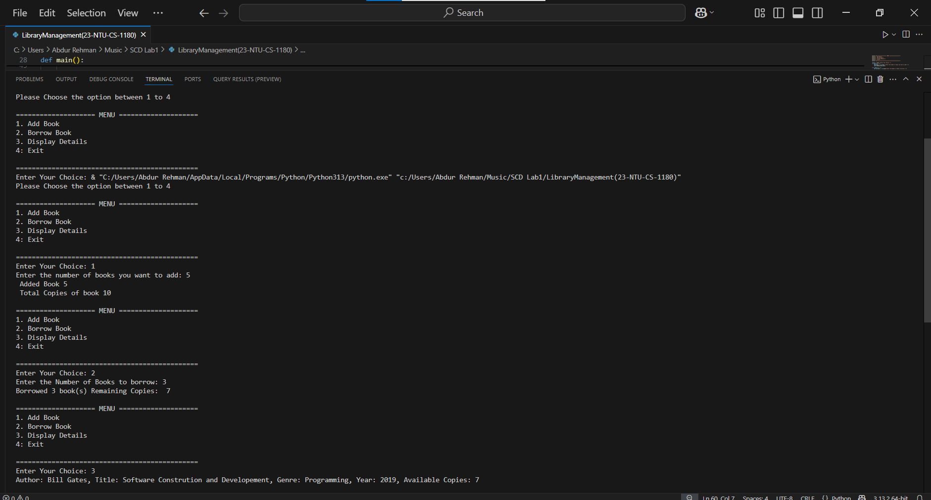

**Lab 3:**

*Library management System using Tkinter*

**Code:**

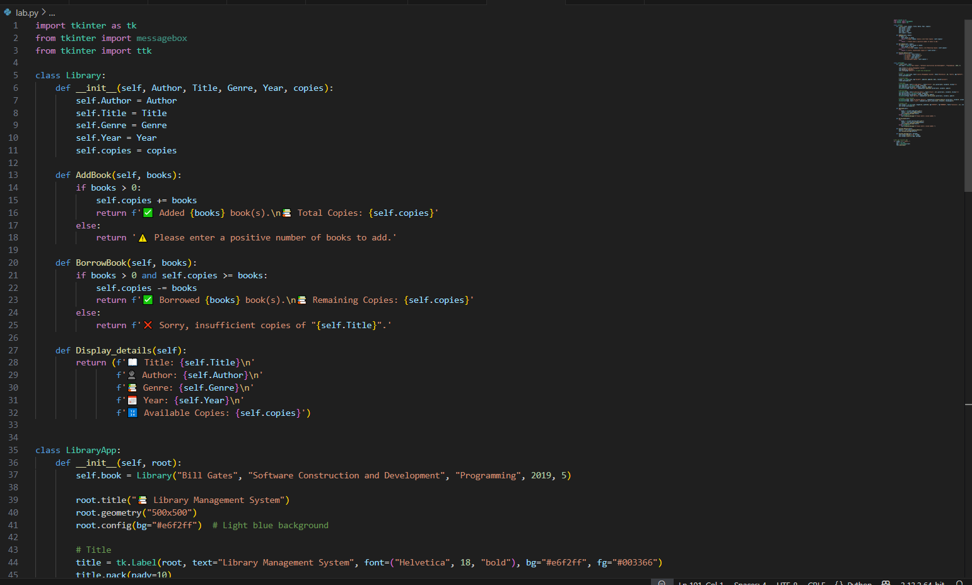

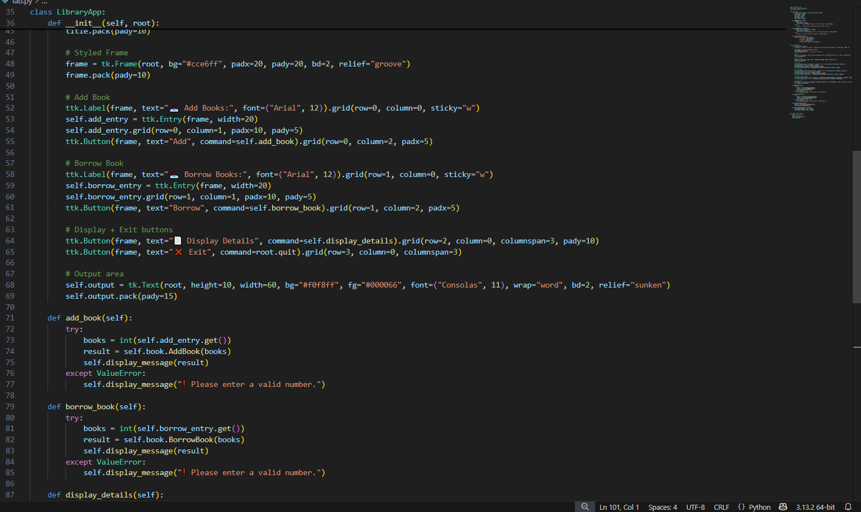

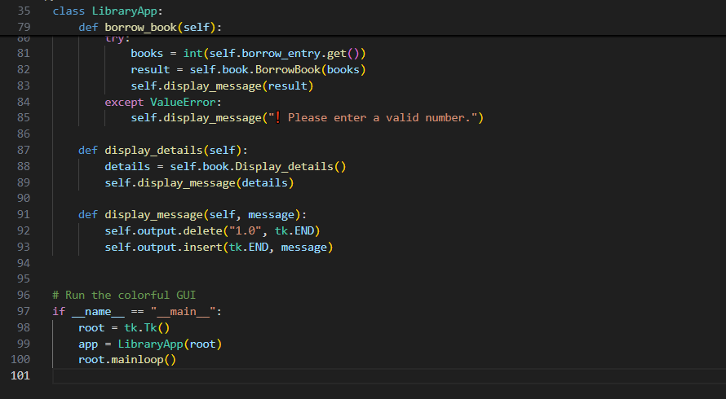

**Output**:

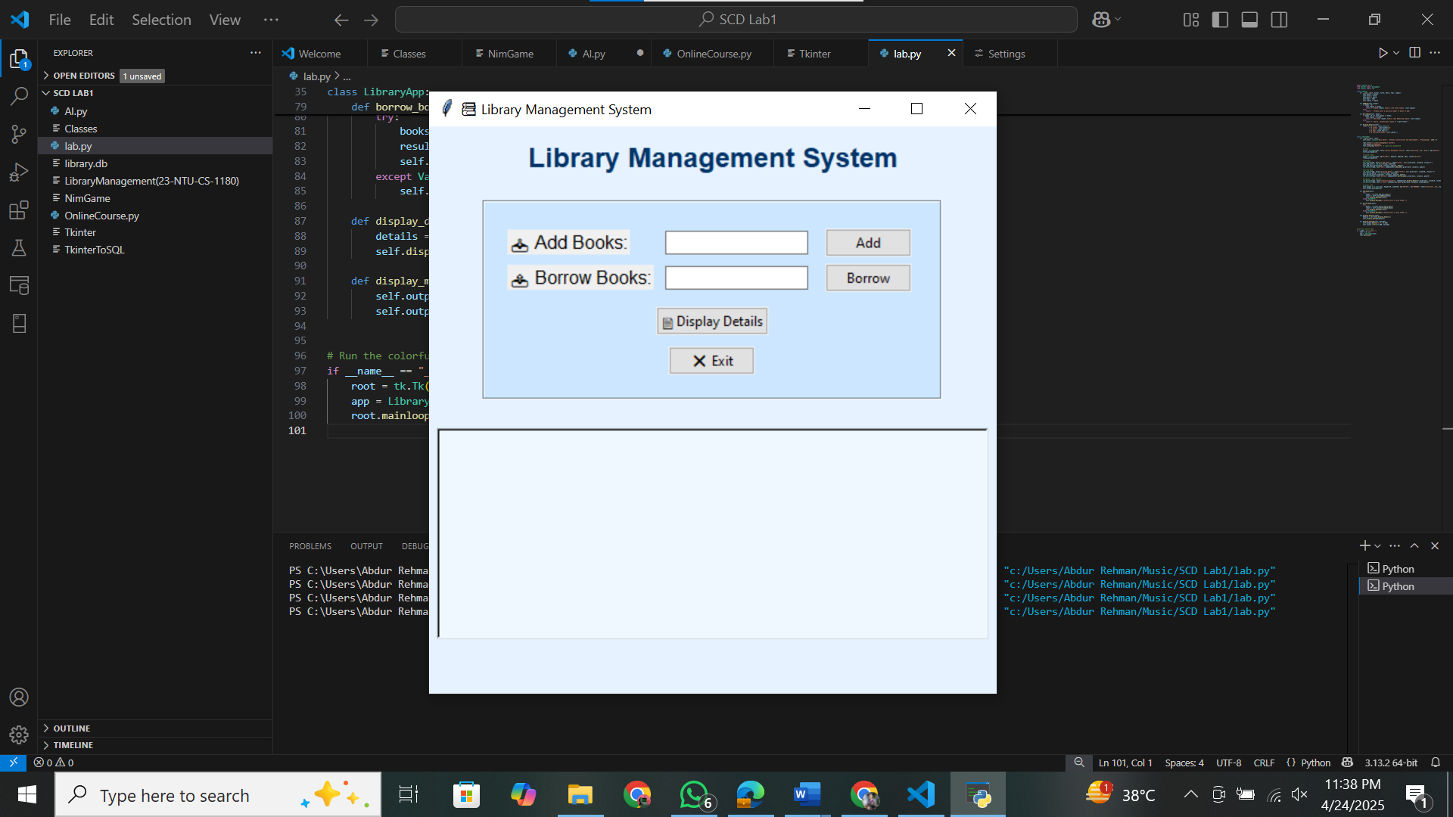

**Lab 4:**

*Library management System using Tkinter and DATABASE*

**Code:**

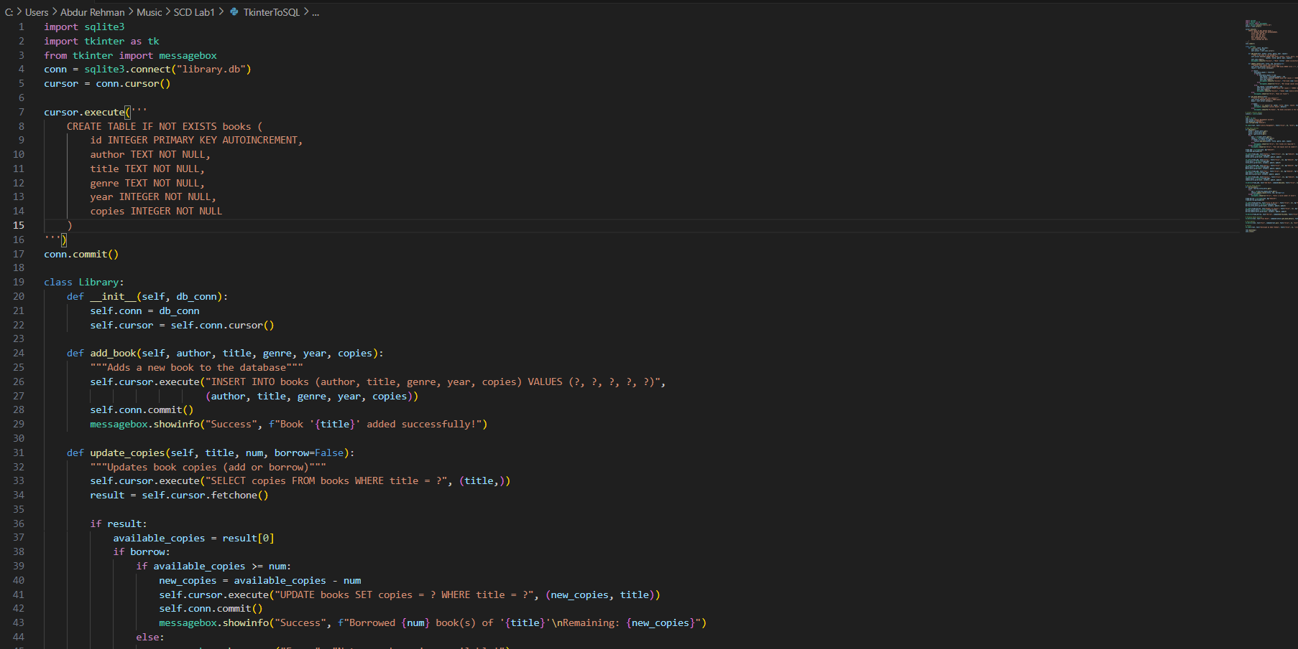

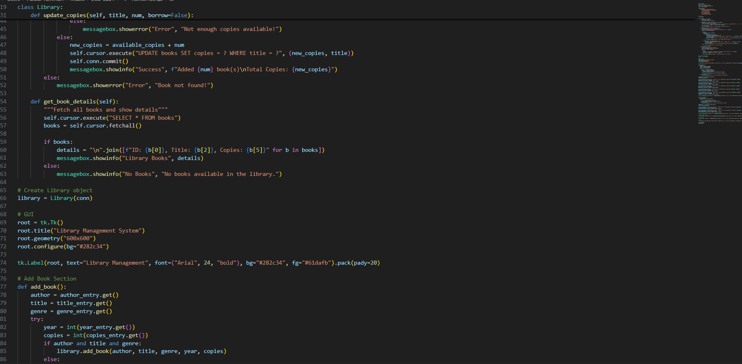

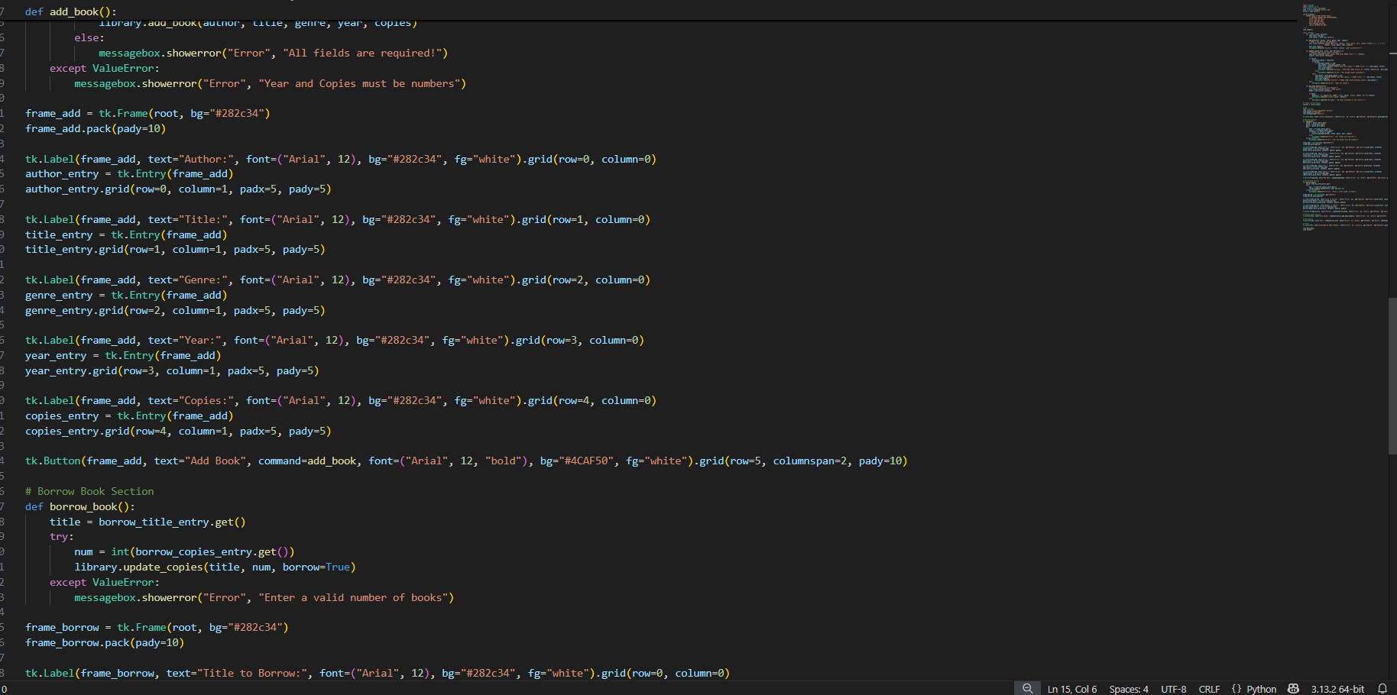

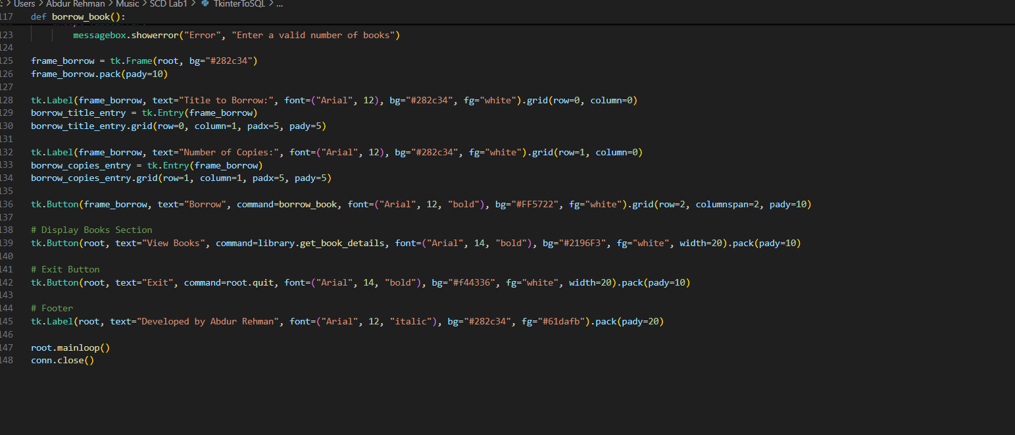

**Output**:

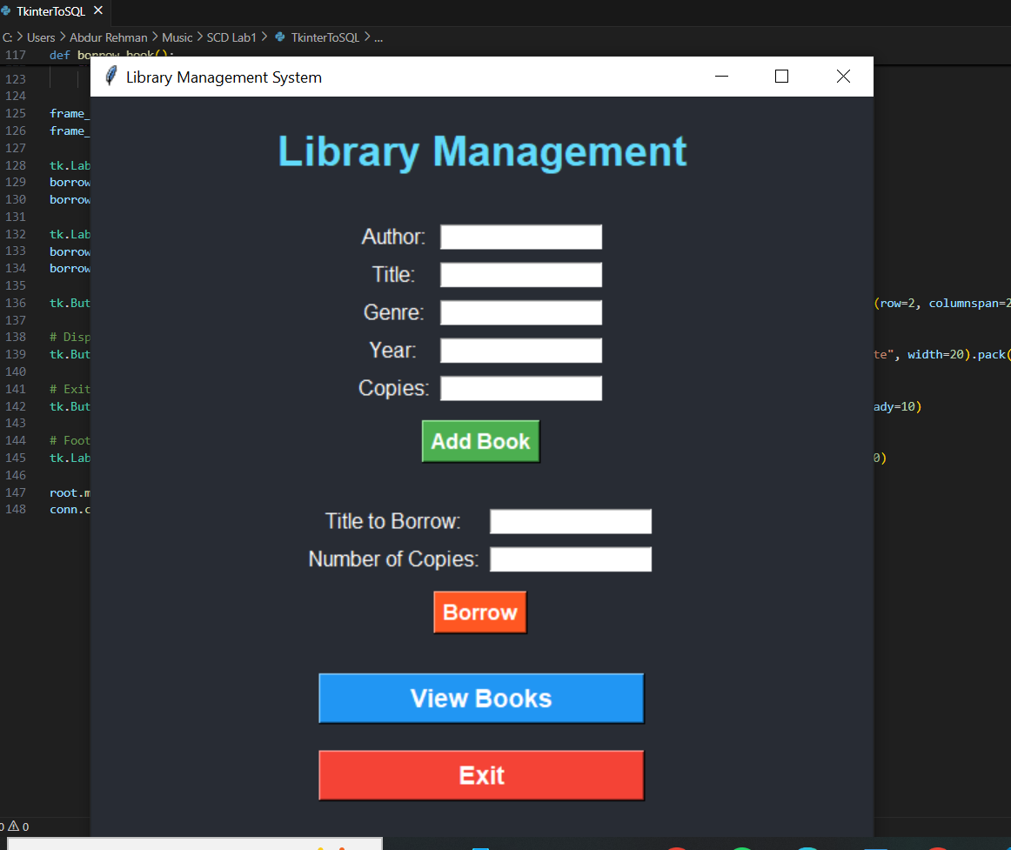

**-------------------------------------------------------------------------------------**

**Lab 5:**

*Tuple Code*

**Code:**

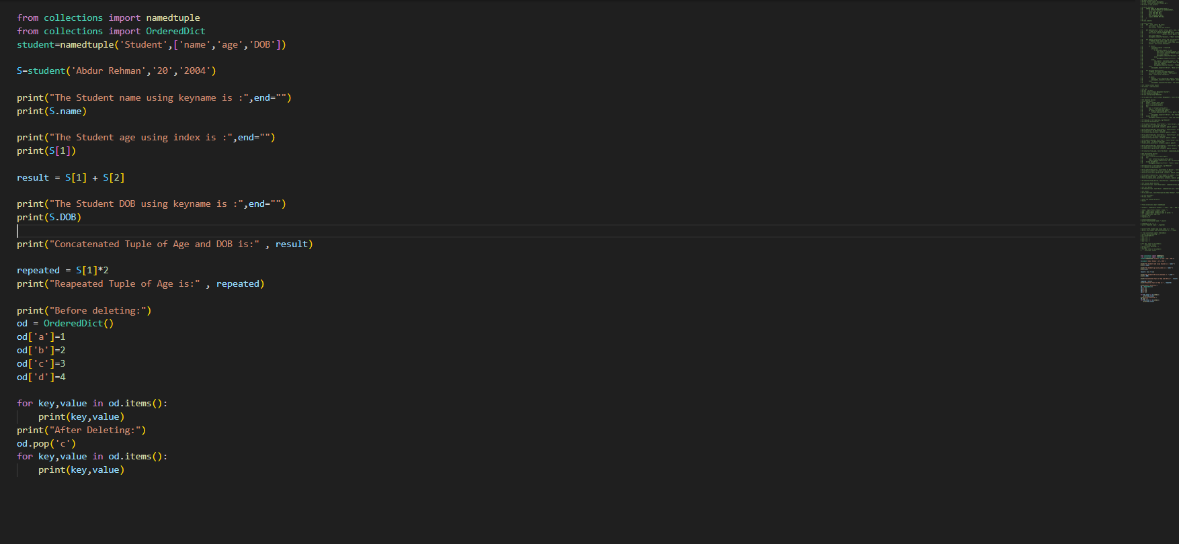

**Output**:

